TEST YOUR KNOWLEDGE
- Why does love make Helena and Demetrius miserable?
- Would you say that Shakespeare remind us that love is often blind? Why?
- List at least three other Shakespearean plays where love is a driving force.
- In Shakespeare “ A Midsummer Night’s Dream” love is depicted in many ways but it appears to be a very funny element through the whole play. On the contrary, identify three other plays where Shakespeare focuses on the tragic power of love.
- Describe the effect of Puck’s spell on Bottom as well as on characters around him.
- Define the magic element in at least 2 scenes of the play analysing how this contributes to creating comedy. ● Analyse the patriarchal element in the play and write down at least one example of this power role attitude.
- Can you identify meta theatrical elements in A Midsummer Night’s Dream?
- The theme of jealousy is very relevant for the quartet of lovers. Give some precise examples.
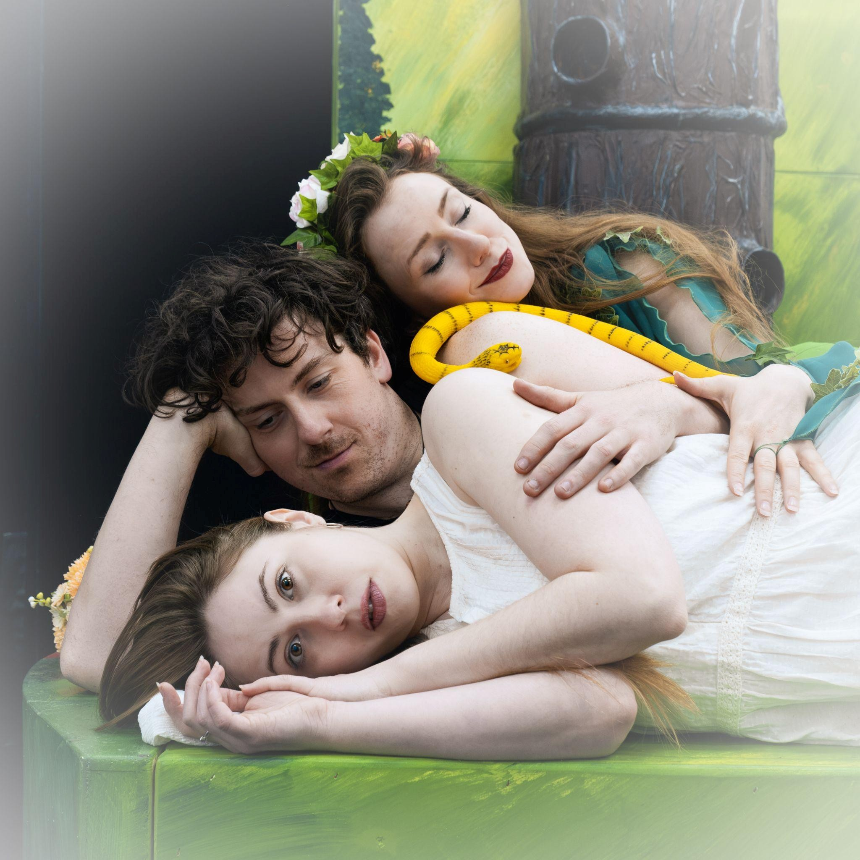
Ph: Alexander Bornschlegl
Comment the following quotes - describing the main themes you can associate to each quote as well as the impact they have on the concerned characters
I beg the ancient privilege of Athens:
As she is mine, I may dispose of her,
Which shall be either to this gentleman Or to her death, according to our law Immediately provided in that case.
A Midsummer Night’s Dream, Act 1, Scene 1
The course of true love never did run smooth
A Midsummer Night’s Dream, Act 1, Scene 1
Relent, sweet Hermia: and, Lysander, yield Thy crazed title to my certain right. A Midsummer Night’s Dream, Act 1, Scene 1
The more I love, the more he hateth me.
A Midsummer Night’s Dream, Act 1, Scene 1
To say the truth, reason and love keep little company together nowadays.
A Midsummer Night’s Dream, Act 3, Scene 2
I have had a most rare vision. I had a dream, past the wit of man to say what dream it was… The eye of man hath not heard, the ear of man hath not seen, man's hand is not able to taste, his tongue to conceive, nor his heart to report, what my dream was.
A Midsummer Night’s Dream, Act 4, Scene 2

Essay - Writing
Gender roles through the centuries.
From A Midsummer Night’s Dream Greece to Shakespeare’s Elizabethan era, with a strong focus on today’s reality.

