ALICE IN WONDERLAND
QUESTIONS FOR DISCUSSION

- Why do you think Alice followed the White Rabbit down the rabbit hole?
- What is Alice like? How would you describe her character?
- How does Alice change throughout her journey? Both physically and in any other ways.
- What would it be like to get bigger and smaller?
- What do you think about the eating and drinking in the story, and how it relates to Alice’s size and her identity?
- Who is your favourite character that Alice meets? Why?
- If you could have tea with any character who would you choose?
- What parts of the play resonated with you the most? And why?
- Lewis Carroll intended the book to be a story without moral lessons. Do you agree? Or are there any lessons to be learned from the trip to Wonderland.
- Did you enjoy the songs in the show? In the original book there are poems. Did the music help you to enjoy the crazy characters?
- Did the play make you think about childhood and what it means to grow up?
- How does Wonderland blur the lines between reality and dreams?
- What does the play suggest about the nature of justice and authority?
- What do you think of Wonderland? Is it a Utopia? Or a lawless society?
- Do the themes of Alice relate to your own observations about the world?
- Alice is a book just for children. Do you agree?
- How does the story challenge our expectations of logic and reason?
- Do you think Alice really went to Wonderland? Or was it all just a dream?
- Why do you think that the nonsense characters became so iconic? We’ve all heard of the White Rabbit, the Mad Hatter and the like, even if we haven’t read the book. Why are these characters still known after over 100 years?
- Alice returns to Wonderland in the sequel “Through the Looking Glass”. What do you think happens ?

ALICE IN WONDERLAND BY LEWIS CARROLL Some notes that might be useful or interesting.
“Alice’s Adventures in Wonderland” commonly known as “Alice in Wonderland” was published in 1865.
Lewis Carroll was a mathematics professor at the University of Oxford. His real name was Charles Dodgson. The artist John Tenniel provided wood-engraved illustrations for the book.
The story of Wonderland came about when, during a picnic outing, 10 year old Alice Liddell asked Charles Dodgson for a story to entertain her and her sisters. Dodgson regaled the girls with tales of a girl named Alice who fell into a rabbit hole and afterwards Alice Liddell begged him to write it down for her. He promised to do so and many months later he presented her with a manuscript entitled “Alice’s Adventures Underground”. In the meantime he had decided to rewrite the story as a commercial venture.
The book received positive reviews on publication and is now one of the best known works of Victorian literature. It is credited with ushering in a new era of children’s literature, moving away from instructive texts and into ones which are aimed at delighting and entertaining children instead.
Since publication the book has never been out of print and has been translated into 174 languages.
It tells the story of a girl who falls through a rabbit hole into a fantasy world populated by strange creatures. It’s a classic work of literary nonsense featuring characters that have come to be iconic. Like the Mad Hatter and the Cheshire Cat.
Alice in Wonderland has had a lasting impact on literature and culture, inspiring countless interpretations and adaptations.
Some critics read “Alice” as a version of Carroll’s life. Saying Alice is based on Alice Liddell and that the Dodo is Carroll himself, even the Mad Hatter’s Tea Party is a version of Alice’s own birthday party. But other critics say that the character of Alice bears little relationship to the real Alice Liddell. And Carroll always said that his character was entirely fictional.
Some readers believe that the book critiques Victorian attitudes towards childhood. Alice’s mistreatment by the creatures of Wonderland echoes how children were treated. Ignored and frustrated by seemingly illogical rules and requests.
Modern critics have enjoyed the way that Alice defies the gendered mid-Victorian conceptions of little girls. Alice does not have a gentle feminine temperament and she challenges the adult figures in Wonderland, often correcting them when she thinks they are wrong.

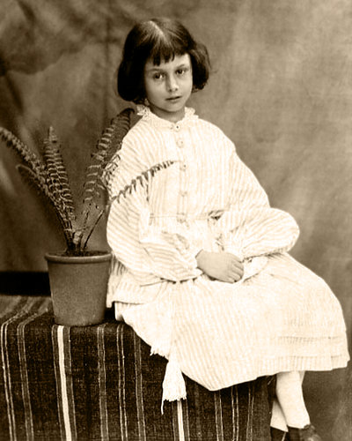
ALICE LIDDELL
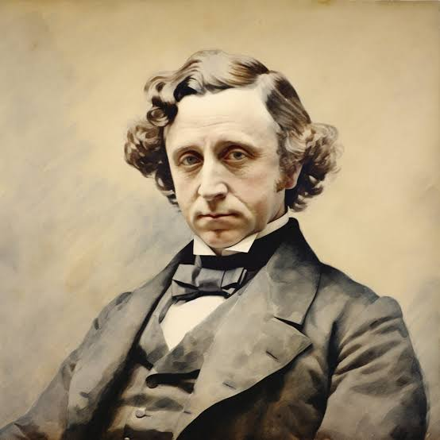
LEWIS CARROLL

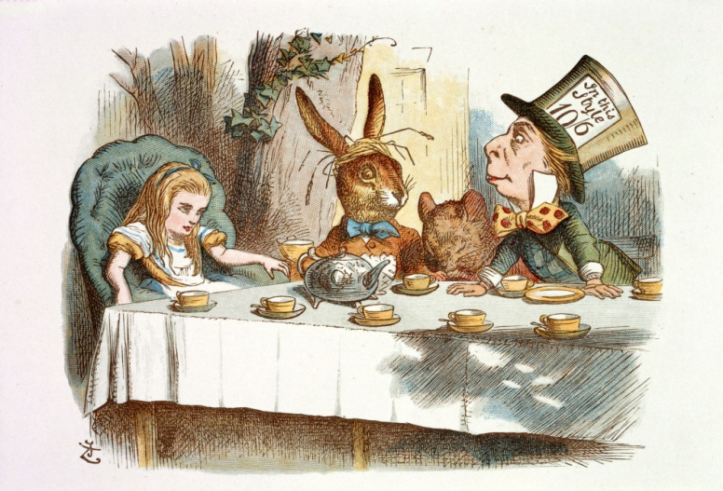

AN ILLUSTRATION FROM THE ORIGINAL BOOK

